***PROJECT PROPOSAL***

**1 - Research project title**

Multi-Omics Meet Art and Archaeology

**2 - Key words**

omics, cultural heritage, microbial communities

**3 - Research project abstract**

Serious concerns regarding our tangible cultural heritage arise from biodeterioration, a process that involves complex ecological interplay among organisms, whose molecular mechanisms are still poorly understood. Multi-omics approaches, each of which generates huge amount of data, have recently been applied to artistic or archaeological objects, with the goal of either contributing to shedding light on the original context of the pieces and/or to inform conservation approaches. The application and the integration of metaproteomics and metagenomic approach to the field of cultural heritage is still in its infancy, and demands for dedicated efforts that will combine the huge amount of data that can eventually lead, beside the simple knowledge of the state of conservation of the specific piece of art, to the development of targeted prevention program. In this perspective, starting from a collection of painting tests on which microrganisms communities will be cultivated and identified, a integrated metaproteomics and metagenomics approach will be used to characterize the activities that synergically can contribute to biodeterioration of the organic components of the painting surface.

**4 - State of the art**

Multi-omics can informally be described as the combined use of high-throughput techniques allowing the characterization of complete microbial communities by the sequencing/identiﬁcation of total pools of biomolecules including DNA, proteins or metabolites.

These techniques have allowed an un precedented level of knowledge on complex microbial ecosystems, which is having key implications in land and marine ecology, industrial biotechnology or biomedicine. Only recently, multi-omics have been applied to artistic or archaeological objects, with the goal of either contributing to shedding light on the original context of the pieces and/or to inform conservation approaches.

In particular, metagenomics can be central for the identiﬁcation of the microbial key-players on artworks surfaces, whose conservation can then be approached by a range of techniques, including using selected microorganisms as ‘probiotics’ because of their direct or indirect effect in the stabilization and preservation of valuable art objects. Beyond taxonomic characterization and the eventual description of new taxa, a major goal of metagenomics is the artiﬁcial modiﬁcation of the micro-biome, often with the objective of improving the pieces’ conservation.

Using mass spectrometry (MS)-based proteomics profiling as a tool for characterizing the microbiome living on archaeological and artistic objects is still unconventional. However, it has the potential to provide information about the functional and active microbiome through revealing the levels of individual proteins expressed by different organisms. Furthermore, meta- proteomics can identify the proteins present within the artistic or archaeological object, and thus, give further insights into possible interactions between the object and the active organisms.

Proteomics and metabolomics can provide paradigm-breaking results by unambiguously identifying peptides associated with a given, palaeo-cultural context. Combination of metagenomics and metaproteomics can indeed offer insights into the function of complex microbial communities, while it is also capable of revealing microbe–microbe and host–microbe interactions. Moreover, different biomolecules such as lipids and secondary metabolites can be analyzed through metabolomics, by using GC–MS (gas chromatography coupled to mass spectrometry) to investigate the composition of art elements and prehistoric objects as well as specific metabolites differentially synthetized by the living organisms such as the biofilm layers on the object’s surface.

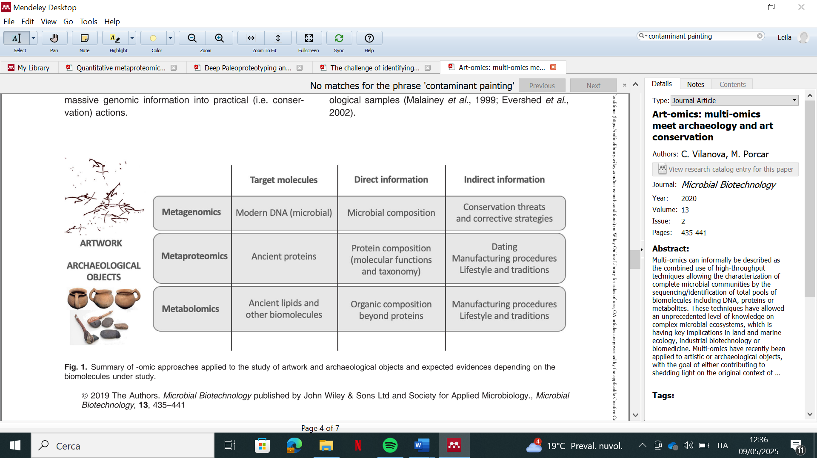

From*: C. Vilanova, M. Porcar, Art-omics: multi-omics meet archaeology and art conservation, Microb. Biotechnol. 13 (2020) 435–441. doi:10.1111/1751-7915.13480.*

The advent of recent technological improvements in experimental approaches have allowed meta-omics to transition from small studies to large-scale experiments, generating an huge amount of data that are challenging for management and integration.

Multi-omics have arisen as a new range of techniques that have proven helpful to either indirectly calculating the chronology or the cultural context of the pieces, as well as to provide relevant information on potential microbial degraders and stabilizers of the objects.

**5 - Objectives and results that the project aims to achieve**

The main advantages of -omic technologies for research in the cultural heritage field would steam from their untargeted nature and the high-throughput generation of data, since they are able to simultaneously yield information on a broad repertoire of biomolecules present in a sample. Hence, with the same amount of sample used in traditional biomolecular analysis to obtain information on a given molecule, omic technologies are able to generate an exhaustive dataset on thousands of molecules. The principal aims of this project are to set up good practise multi-omics protocol to face biodeterioration of cultural heritage by/and the use of painting surfaces as starting set of samples.

**6 - Scientific and/or technological and/or social and/or economic impact of the project**

Multi-omics have arisen as a new range of techniques that have proven helpful to either indirectly calculating the chronology or the cultural context of the pieces, as well as to provide relevant information on potential microbial degraders and stabilizers of the objects.

The two main advantages of -omic technologies for archaeological research are their untargeted nature and the high-throughput generation of data, since they are able to simultaneously yield information on a broad repertoire of biomolecules present in a sample.

The use of non-targeted omics strategies requires high-resolution and sensitive analytical technologies to capture as many analytes as possible and to increase the information content accordingly. Very large data sets are inevitably generated using omics approaches, and bioinformatic and chemometric methods must be used for data evaluation. Bioinformatic approaches primarily include sequence analysis and are used in genomics and proteomics datasets. Data evaluation should not be underestimated and, depending on the selected omics approach and the data structure, can involve a great deal of time and effort. The bioinformatics workflow required for metaproteomics research, from the database search and protein quantification to downstream functional and taxonomic analysis has been challenging and thus limiting the accessibility of metaproteomics to microbiome researchers. By combining the various omics levels, a comprehensive elementary and molecular profile can be created about an object and a maximum depth of information can be generated that can eventually lead, beside the simple knowledge of the state of conservation of the specific piece of art, to the development of targeted prevention program.

**7 - Methodologies that are planned to be used** (Max. 1000 characters)

In this research project, a metaproteogenomics analysis of samples constituted by microbial communities grown on different combinations of pigments/proteinaceous binders (namely, egg, milk and glue from hides, the usual ones used in tempera paintings) will be explored to investigate possible variation of the protein/activity profile upon binder and/or pigment. Ideally, 4 pigments for three binders (egg, milk and glue from hides) plus three samples of binders without any pigment will be the substrates on which microbial communities or isolated microorganisms will be grown.

Then metaproteogenomics analyses and metabolomics analyses will be carried out.

In a metaproteogenomics approach, such as that proposed by Unipept Desktop application analysis pipeline depicted below, tries to overcome this problem by exploiting information from prior metagenomic data experi- ments from the same environment. The metagenomics experiment is used to explore the taxonomic composition of an ecosystem, which subsequently guides the researcher to query only a subset of the reference database in the subsequent metaproteomics experiment.

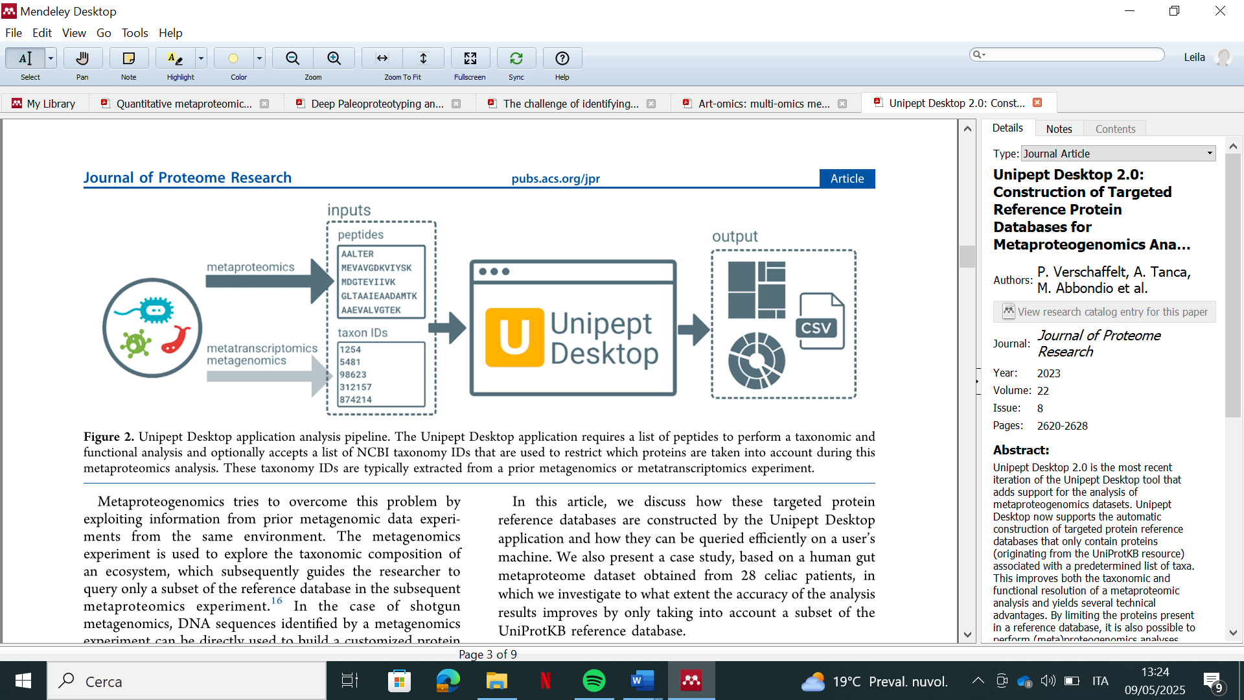

From: *P. Verschaffelt, et al., Unipept Desktop 2.0: Construction of Targeted Reference Protein Databases for Metaproteogenomics Analyses, J. Proteome Res. 22 (2023) 2620–2628. doi:10.1021/acs.jproteome.3c00091*.

**8- *PI***

**First and last name: Alessandro Vergara (Full Professor of Physical Chemistry, CHIM-02)**

**PI bibliography:**

**H-index =**30

**Number published papers in the last 5 years:** 22

**I.F. of best publications in the last 5 y:** 14, 14, 9, 5, 5

**PI’s publications most relevant to the project (biomolecules metalation)**

[Microplastics, microfibers and associated microbiota biofilm analysis in seawater, a case study from the Vesuvian Coast, southern Italy](https://scholar.google.it/citations?view_op=view_citation&hl=it&user=T1fDMo8AAAAJ&sortby=pubdate&citation_for_view=T1fDMo8AAAAJ:uVUOdF_882EC), M Rossi, A Vergara, R Troisi, M Alberico, F Carraturo, M Salamone, ...Journal of Hazardous Materials, 137468 (2025)

[Deterioration-associated microbiome of a modern photographic artwork: the case of *Skull and Crossbones* by Robert Mapplethorpe](https://scholar.google.it/citations?view_op=view_citation&hl=it&user=T1fDMo8AAAAJ&sortby=pubdate&citation_for_view=T1fDMo8AAAAJ:rHJHxKgnXwkC), M Petraretti, A De Natale, A Del Mondo, R Troisi, O De Castro, N Mormile, ..., Heritage Science 12 (1), 172 (2024)

[On the Identification of the a fresco or a secco Preparative Technique of Wall Paintings.](https://scholar.google.it/citations?view_op=view_citation&hl=it&user=T1fDMo8AAAAJ&sortby=pubdate&citation_for_view=T1fDMo8AAAAJ:Ade32sEp0pkC), G Ntasi, M Rossi, M Alberico, A Tomeo, L Birolo, A Vergara, Heritage (2571-9408) 7 (8) (2024)

[Mechanism of Be-Thermodiffusion in Rutile Inclusions of Fancy Sapphires](https://scholar.google.it/citations?view_op=view_citation&hl=it&user=T1fDMo8AAAAJ&sortby=pubdate&citation_for_view=T1fDMo8AAAAJ:4vMrXwiscB8C), M Rossi, R Biondi, R Rizzi, N Corriero, F Sequino, A Vergara, Crystal Growth & Design 22 (11), 6493-6503 (2022)

[On the productive function of furnaces in archaeological sites](https://scholar.google.it/citations?view_op=view_citation&hl=it&user=T1fDMo8AAAAJ&cstart=20&pagesize=80&sortby=pubdate&citation_for_view=T1fDMo8AAAAJ:4fGpz3EwCPoC), M Rossi, N De Riso, M Caterino, G Ferraro, L Cicala, B Ferrara, ..., Journal of Raman Spectroscopy 52 (1), 217-229 (2021)

[Combating actions of green 2D-materials on gram positive and negative bacteria and enveloped viruses](https://scholar.google.it/citations?view_op=view_citation&hl=it&user=T1fDMo8AAAAJ&cstart=20&pagesize=80&sortby=pubdate&citation_for_view=T1fDMo8AAAAJ:9pM33mqn1YgC), M Singh, C Zannella, V Folliero, R Di Girolamo, F Bajardi, A Chianese, ..., Frontiers in Bioengineering and Biotechnology 8, 569967 (2021)

**9 - Technical and economic sustainability of the project** (Max. 1000 characters)

A. Vergara is expert in Raman and IR microscopies that are useful to study chemical degradation of entity of Cultural Heritage. The project is in collaboration with other researchers of Dept. Chemical Sciences and Biology the University of Naples Federico II. They will combine their expertise to ensure that the candidate will achieves the objectives of this project. In particular, L. Birolo is an expert in Proteomics and Prof. Pollio is expert on metagenomics. The foreign colleagues will integrate their skills for the period abroad. Moreover, funds are available (PNRR and ERC on the subject).

**10 - Other possible participants**

**-Antonino Pollio (Dept. Biology.-UNINA)**

**-Enrico Cappellini, PhD, Associate Professor in Paleoproteomics, Globe Institute, Section for Geogenetics,    University of Copenaghen, Denmark.**

**-Caroline Tokarski, Professor of Analytical Chemistry, at the University of Bordeaux, France**

**11 - Scientific publications, relevant to the project, of participants, other than PI**

**-**Liguori, R, Pennacchio, A, Vandenberghe, LPD, De Chiaro, A, **Birolo, L.,** Soccol, CR, Faraco, V. Screening of Fungal Strains for Cellulolytic and Xylanolytic Activities Production and Evaluation of Brewers' Spent Grain as Substrate for Enzyme Production by Selected Fungi. 2021 Energies, 14, 4443. Doi: 10.3390/en14154443

**-** Corrado, I, Cascelli, N, Ntasi, G, **Birolo, L.,** Sannia, G, Pezzella, C. Optimization of Inulin Hydrolysis by Penicillium lanosocoeruleum Inulinases and Efficient Conversion into Polyhydroxyalkanoates. 2021 Frontiers in Bioengineering and Biotechnology, 9, 616908, DOI: 10.3389/fbioe.2021.616908.

**-** Ntasi, G, Kirby, DP, Stanzione, I, Carpentieri, A, Somma, P, Cicatiello, P, Marino, G, Giardina, P, **Birolo, L.** A versatile and user-friendly approach for the analysis of proteins in ancient and historical objects. 2021 J Proteomics 231, 104039. Doi: 10.1016/j.jprot.2020.104039. Corresponding author

**-** Raineri, D.; Dianzani, C.; Cappellano, G.; Maione, F.; Baldanzi, G.; Iacobucci, I.; Clemente, N.; Baldone, G.; Boggio, E.; Gigliotti, C. L.; Boldorini, R.; Rojo, J. M.; Monti, M.; **Birolo, L.;** Dianzani, U.; Chiocchetti, A. Osteopontin binds ICOSL promoting tumor metastasis. 2020 Commun Biol 3, 615 http://dx.doi.org/10.1038/s42003-020-01333-1

**-** Pitocchi, R., Cicatiello, P., **Birolo, L.,** Piscitelli, A., Bovio, E., Varese, G.C., Giardina, P. Cerato-Platanins from Marine Fungi as Effective Protein Biosurfactants and Bioemulsifiers. 2020 Int. J. of Mol. Sci., 21, 2913

- Melchiorre, C., Dello Ioio, L., Ntasi, G., **Birolo, L**., Trojsi, G., Cennamo, P., Barone Lumaga, M.R., Fatigati, G., Amoresano, A., Carpentieri, A. A multidisciplinary assessment to investigate a XXII dynasty wooden coffin. 2020 Int. J. Conserv. Sci., 11, 25-38.

- Cicatiello P., Stanzione I., Dardano P., De Stefano L., **Birolo L**., De Chiaro A., Monti D. M., Petruk G., D'Errico G., Giardina P. Characterization of a surface-active protein extracted by a marine strain of *Penicillium chrysogenum*. 2019 Int. J. of Mol. Sci., 20, 3242, https://doi.org/10.3390/ijms20133242

- P. Petrone, P. Pucci, A. Vergara, A. Amoresano, **L. Birolo**, F. Pane, F. Sirano, M. Niola, C. Buccelli, V. Graziano. A hypothesis of sudden body fluid vaporization in the 79 AD victims of Vesuvius. 2018 PLoS ONE 13(9): e0203210. https://doi.org/10.1371/journal.pone.0203210. IF 2.766

- R. Vinciguerra, A. Illiano, A. De Chiaro, A. Carpentieri, A. Lluveras-Tenorio, I. Bonaduce, G. Marino, P. Pucci, A. Amoresano, **L. Birolo**. Identification of proteinaceous binders in paintings: A targeted proteomic approach for cultural heritage. Microchemical Journal, 2018, 144, 319-328. https://doi.org/10.1016/j.microc.2018.09.021 IF 2.746. Corresponding author

- Linn R, Bonaduce I, Ntasi G, **Birolo L**, Yasur-Landau A, Cline EH, Nevin A, Lluveras-Tenorio A. Evolved Gas Analysis-Mass Spectrometry to Identify the Earliest Organic Binder in Aegean Style Wall Paintings. Evolved Gas Analysis-Mass Spectrometry to Identify the Earliest Organic Binder in Aegean Style Wall Paintings.2018 Angew Chem Int Ed Engl. 2018 Aug 10. doi: 10.1002/anie.201806520. IF 12.102

- Cicatiello P, Ntasi G, Rossi M, Marino G, Giardina P, **Birolo L.** Minimally Invasive and Portable Method for the Identification of Proteins in Ancient Paintings. 2018 Anal Chem. 90(17):10128-10133. doi: 10.1021/acs.analchem.8b01718. IF 6.042 Corresponding author

- Capitini C, Patel JR, Natalello A, D'Andrea C, Relini A, Jarvis JA, **Birolo L**, Peduzzo A, Vendruscolo M, Matteini P, Dobson CM, De Simone A, Chiti F. Structural differences between toxic and nontoxic HypF-N oligomers. 2018, Chem Commun 54(62):8637-8640. doi: 10.1039/c8cc03446j. IF 6.29

- Piscitelli A., Tarallo V., Guarino L., Sannia G., **Birolo L**., Pezzella C. New lipases by mining of *Pleurotus ostreatus* genome. 2017, PLoS ONE 12(9): e0185377. DOI: 10.1371/journal.pone.0185377. IF 2.766